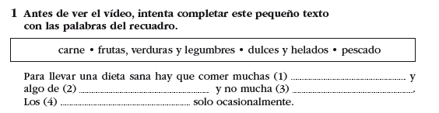

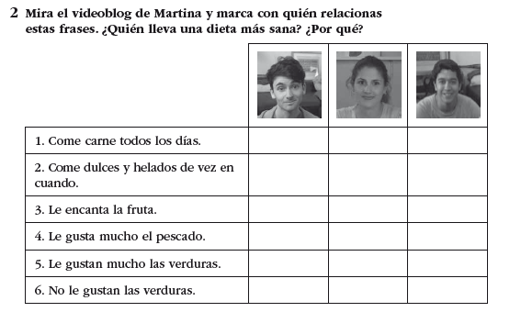

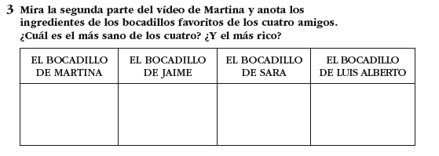

Vídeo: <https://www.youtube.com/watch?v=XGAU-pHUi-w&list=PLdzqcdsXmqB9u-x1mXG9_QYw-P6ZbcY53&index=6>